23CSE202 DATABASE MANAGEMENT SYSTEMS
S3 B.Tech CSE
Department of Computer Science and Engineering
Amrita School of Computing, Amritapuri Campus
3. Database Design Document
Group No : D14

Team Members :
Roll No | Student Name
AM.SC.U4CSE25324 | Jeevan A Jacob
AM.SC.U4CSE25342 | Prithew J Raj
AM.SC.U4CSE25349 | Siddharth S
AM.SC.U4CSE25363 | Kalidas R Unnithan
AM.SC.U4CSE25367 | Tanishq Q T

Project Title : Library Management System
3.1. Detailed description of the project
1. Project Scenario
The Library Management System (LMS) is a relational-database-driven application designed to digitise and centralise the daily operations of an academic library. It manages books, authors, publishers, categories, librarians, members, borrowing transactions, fines, reservations, and feedback.
The system supports three application roles: Administrators, Librarians, and Members. Administrators have additional privileges for managing librarian accounts and viewing library-wide reports. Librarians manage the book catalog and process book issues and returns. Members, including students and faculty, can search the catalog, borrow and reserve books, track their due dates and fines, and submit feedback and ratings.
An Administrator is not maintained as a separate database entity. Instead, an administrator is represented as a row in the LIBRARIAN entity with the role attribute set to admin. A normal librarian has the role value librarian, and the application grants additional administrative privileges based on this attribute.
The library maintains a catalog of books. Each book belongs to exactly one publisher and one subject category, while a publisher or category can be associated with many books. A book can have one or more authors, and an author can write multiple books, creating a many-to-many relationship between BOOK and AUTHOR.
Since multiple physical copies of the same book title may be available in the library, the BOOK entity maintains the total number of copies procured and the number of copies currently available for issue.
When a member borrows a book, a borrowing transaction is created. The transaction records the member, book, librarian who processed the issue, issue date, due date, and return date. The return date remains empty until the book is returned. If the book is returned after the due date, an overdue fine is generated and linked to that borrowing transaction.
Members can reserve a book when all its copies are currently unavailable. A reservation is associated with a member and a book and has a status indicating whether it is pending, fulfilled, cancelled, or expired. A pending reservation expires automatically if the member does not collect the book within the configured period after it becomes available.
Members may also submit feedback and star ratings either for the library in general or for a specific book.

2. Entities and Attributes
The ER diagram contains the following Ten main entities.
a) MEMBER
- member_id – Primary Key: unique identifier for each library member.
- name, email, phone, address
- member_type – identifies whether the member is a student or faculty member.
- registration_date
- status – indicates whether the member is active or inactive.
- unpaid_fine_amount – stores the member's outstanding fine amount.
b) LIBRARIAN
- librarian_id – Primary Key: unique identifier for each librarian.
- name, email, password, phone
- role – identifies the user as librarian or admin.
- status
Administrators are represented using this entity with role = 'admin'; therefore, a separate ADMINISTRATOR entity is not required.
c) BOOK
- book_id – Primary Key: unique identifier for each book title.
- title, isbn, publication_year
- publisher_id – Foreign Key to PUBLISHER.
- category_id – Foreign Key to CATEGORY.
- total_copies – total physical copies procured.
- available_copies – copies currently available for issue.
d) AUTHOR
- author_id – Primary Key: unique identifier for each author.
- name
- email
- biography
e) PUBLISHER
- publisher_id – Primary Key.
- name
- address
- phone
- email
f) CATEGORY
- category_id – Primary Key.
- name
- description
g) BORROW
- borrow_id – Primary Key: unique identifier for each borrowing transaction.
- member_id – Foreign Key to MEMBER.
- book_id – Foreign Key to BOOK.
- librarian_id – Foreign Key to LIBRARIAN.
- issue_date
- due_date
- return_date
h) FINE
- fine_id – Primary Key.
- borrow_id – Foreign Key to BORROW.
- amount
- overdue_days
- fine_date
- status
A unique borrow_id ensures that at most one fine is associated with a borrowing transaction.
i) RESERVATION
- reservation_id – Primary Key.
- member_id – Foreign Key to MEMBER.
- book_id – Foreign Key to BOOK.
- reservation_date
- expiry_date
- status

j) FEEDBACK
- feedback_id – Primary Key.
- member_id – Foreign Key to MEMBER.
- book_id – Foreign Key to BOOK; nullable when feedback is about the library in general.
- rating
- comments
- feedback_date

3. Relationships and Cardinalities
a) PUBLISHER — publishes — BOOK
Cardinality: 1 : N
One publisher can publish many books, while each book is published by exactly one publisher.
Relationship:
PUBLISHER (1) → BOOK (N)

b) CATEGORY — classifies — BOOK
Cardinality: 1 : N
One category can contain many books, while each book belongs to exactly one category.
Relationship:
CATEGORY (1) → BOOK (N)

c) BOOK — written_by — AUTHOR
Cardinality: M : N
A book can be written by one or more authors, while an author can write multiple books.
Relationship:
BOOK (M) ↔ AUTHOR (N)
This many-to-many relationship is implemented using an associative relation such as BOOK_AUTHOR.

d) MEMBER — makes — BORROW
Cardinality: 1 : N
One member can make multiple borrowing transactions over time, while each borrowing transaction belongs to one member.
Relationship:
MEMBER (1) → BORROW (N)

e) BOOK — is_borrowed_in — BORROW
Cardinality: 1 : N
One book title can appear in multiple borrowing transactions over time, while each borrowing transaction refers to one book.
Relationship:
BOOK (1) → BORROW (N)

f) LIBRARIAN — processes — BORROW
Cardinality: 1 : N
One librarian can process multiple borrowing transactions, while each borrowing transaction is processed by one librarian.
Relationship:
LIBRARIAN (1) → BORROW (N)

g) BORROW — generates — FINE
Cardinality: 1 : 0..1
A borrowing transaction may generate no fine if the book is returned on time, or one fine if it is returned late.
Relationship:
BORROW (1) → FINE (0..1)
h) MEMBER — places — RESERVATION
Cardinality: 1 : N
One member can place multiple reservations over time, while each reservation belongs to one member.
Relationship:
MEMBER (1) → RESERVATION (N)

i) BOOK — is_reserved_in — RESERVATION
Cardinality: 1 : N
One book can have multiple reservations over time, while each reservation refers to one book.
Relationship:
BOOK (1) → RESERVATION (N)

j) MEMBER — submits — FEEDBACK
Cardinality: 1 : N
One member can submit multiple feedback records, while each feedback record is submitted by one member.
Relationship:
MEMBER (1) → FEEDBACK (N)

k) BOOK — receives — FEEDBACK
Cardinality: 1 : N
One book can receive multiple feedback records, while each book-specific feedback record refers to one book.
Relationship:
BOOK (1) → FEEDBACK (N)
A feedback record may instead be about the library in general, in which case book_id is NULL.

4. System Users
- Administrator: manages librarian accounts, manages system-level settings, and views library-wide analytical reports. Administrators are stored in LIBRARIAN with role = 'admin'.
- Librarian: manages the book catalog, authors, publishers and categories, processes book issues and returns, manages reservations, and handles member borrowing activities.
- Member: searches the book catalog, borrows books, places reservations when books are unavailable, tracks due dates and fines, and submits feedback and ratings.

5. Business Rules
- Every member, librarian, book, author, publisher, category, borrowing transaction, fine, reservation, and feedback record has a unique identifier.
- A publisher can publish multiple books, while every book belongs to exactly one publisher.
- A category can classify multiple books, while every book belongs to exactly one category.
- A book can have one or more authors, and an author can write multiple books. Therefore, BOOK and AUTHOR form a many-to-many relationship.
- A book maintains both total_copies and available_copies. The available-copy count cannot exceed the total-copy count.
- A member can borrow multiple books over time. Each borrowing transaction references exactly one member, one book, and the librarian who processed the transaction.
- A book cannot be issued when available_copies = 0. In such a situation, the member must place a reservation instead. This rule requires a database trigger or application-level validation because it depends on the current value of available_copies.
- The due date is calculated from the issue date using the standard library loan period. The return date remains NULL until the book is actually returned.
- A borrowing transaction generates a fine only when the book is returned after its due date. At most one fine can be associated with a borrowing transaction.
- The fine amount is calculated based on the number of overdue days and the configured daily fine rate. This calculation is handled by the application or a database trigger.
- A member may reserve a book when all copies are currently unavailable. A reservation must eventually be fulfilled, cancelled, or expired.
- A member cannot have multiple unresolved reservations for the same book. This requires a suitable unique constraint, partial/filtered constraint, trigger, or application-level validation.
- A pending reservation expires automatically after the configured reservation period if it is not collected.
- A member whose unpaid fines exceed the configured borrowing threshold is barred from borrowing additional books until the outstanding dues are cleared.
- A librarian may have either librarian or admin as the role value. An administrator is therefore an elevated librarian account rather than a separate database entity.
- A member can submit multiple feedback records. Feedback may be associated with a specific book or may refer to the library in general.
- The star rating must fall within the configured valid range, such as 1 to 5 stars. This can be enforced using a CHECK constraint.

6. Overall Database Workflow
Publisher → Book → Borrow → Member
Category → Book
Book ↔ Author
Librarian → Borrow
Borrow → Fine
Member → Reservation → Book
Member → Feedback → Book / Library
Member → Borrow → Book
Librarian (role = admin) → Librarian Management / Reports
3.2. ER Diagram
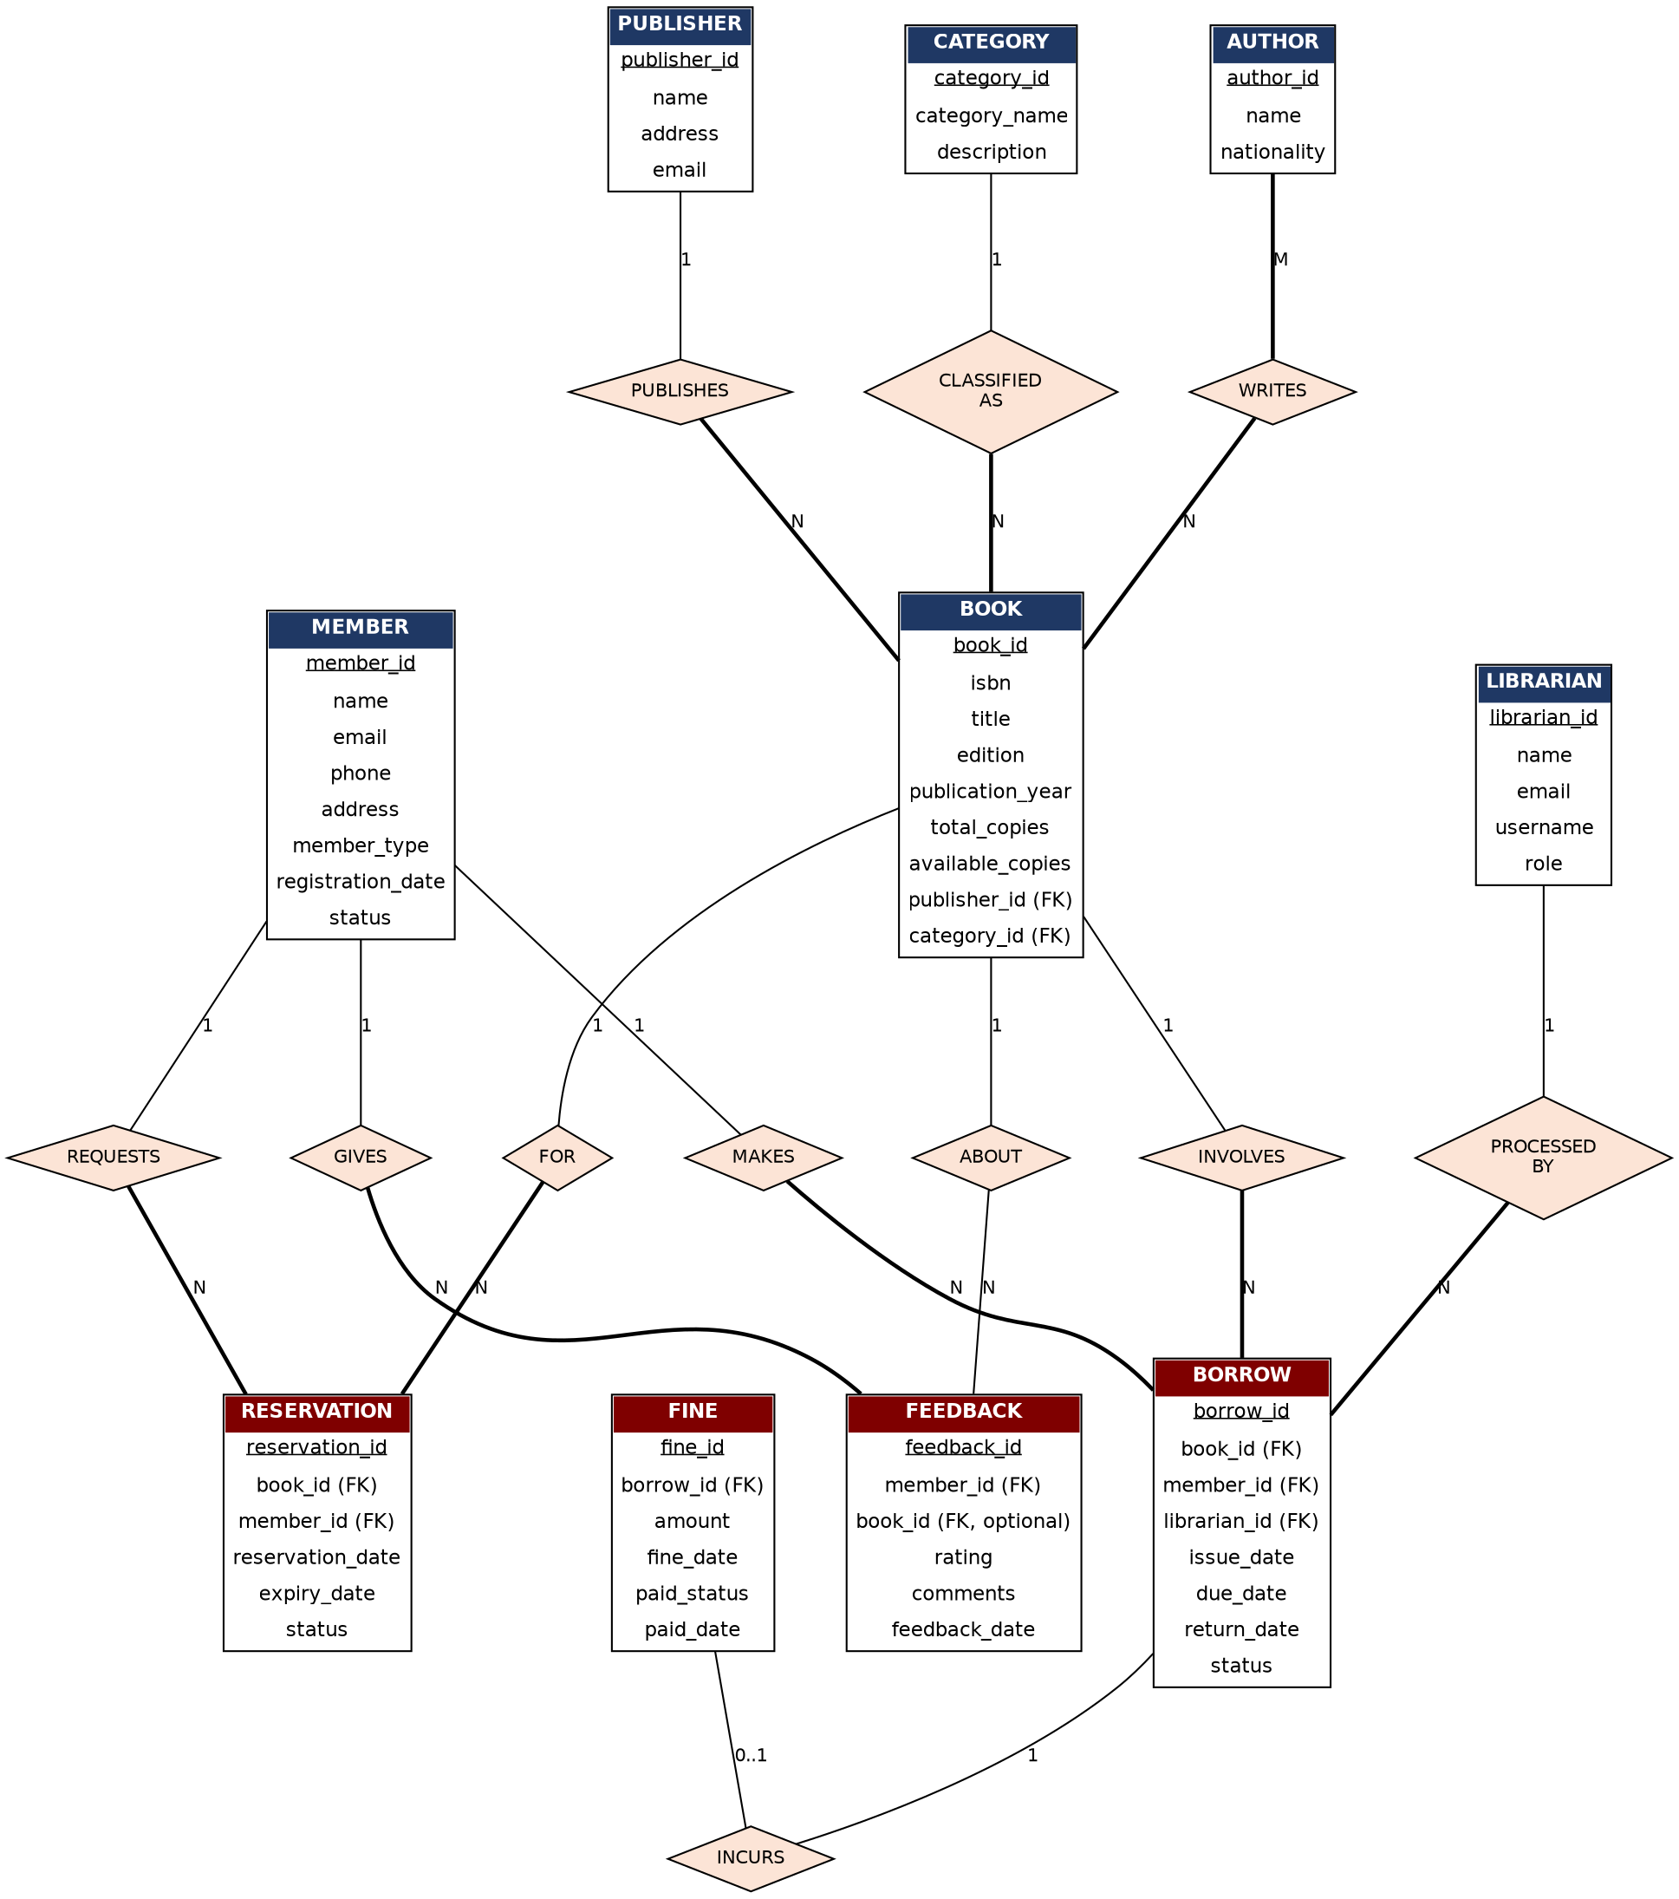
Fig. 3.1 - Entity-Relationship diagram of the Library Management System
Note: Primary keys are underlined; foreign keys are marked (FK). Bold connecting lines denote total (mandatory) participation, thin lines denote partial (optional) participation of an entity in a relationship. Cardinality (1, N, M, 0..1) is marked on each connecting edge.
The relationships shown in the diagram, together with their cardinality and participation constraints, are summarised below:
Relationship | Entities involved | Cardinality | Participation
PUBLISHES | Publisher - Book | 1 : N | Book: total, Publisher: partial
CLASSIFIED AS | Category - Book | 1 : N | Book: total, Category: partial
WRITES | Author - Book | M : N | Author: total, Book: total
PROCESSED BY | Librarian - Borrow | 1 : N | Borrow: total, Librarian: partial
MAKES | Member - Borrow | 1 : N | Borrow: total, Member: partial
INVOLVES | Book - Borrow | 1 : N | Borrow: total, Book: partial
REQUESTS | Member - Reservation | 1 : N | Reservation: total, Member: partial
FOR | Book - Reservation | 1 : N | Reservation: total, Book: partial
INCURS | Borrow - Fine | 1 : 0..1 | Fine: total, Borrow: partial
GIVES | Member - Feedback | 1 : N | Feedback: total, Member: partial
ABOUT | Book - Feedback | 1 : N | Feedback: partial, Book: partial

3.3 Relational Schema
Applying the standard ER-to-relational mapping rules (each strong entity becomes a relation; each 1:N relationship is represented by placing the primary key of the '1' side as a foreign key in the 'N' side; and each M:N relationship is represented by a separate bridge relation containing the primary keys of both participating entities) to the ER diagram in Section 3.2 gives the following relational schema.
PUBLISHER(
publisher_id INT PRIMARY KEY,
name VARCHAR(100),
address VARCHAR(255),
phone VARCHAR(15),
email VARCHAR(100)
)
CATEGORY(
category_id INT PRIMARY KEY,
category_name VARCHAR(100),
description VARCHAR(255)
)
AUTHOR(
author_id INT PRIMARY KEY,
name VARCHAR(100),
nationality VARCHAR(50)
)
BOOK(
book_id INT PRIMARY KEY,
isbn VARCHAR(20) UNIQUE,
title VARCHAR(200),
edition VARCHAR(50),
publication_year INT,
total_copies INT,
available_copies INT,
publisher_id INT,
category_id INT,
FOREIGN KEY (publisher_id) REFERENCES PUBLISHER(publisher_id),
FOREIGN KEY (category_id) REFERENCES CATEGORY(category_id)
)
BOOK_AUTHOR(
book_id INT,
author_id INT,
PRIMARY KEY (book_id, author_id),
FOREIGN KEY (book_id) REFERENCES BOOK(book_id),
FOREIGN KEY (author_id) REFERENCES AUTHOR(author_id)
)
MEMBER(
member_id INT PRIMARY KEY,
name VARCHAR(100),
email VARCHAR(100) UNIQUE,
phone VARCHAR(15),
address VARCHAR(255),
member_type VARCHAR(20),
registration_date DATE,
status VARCHAR(20)
)
LIBRARIAN(
librarian_id INT PRIMARY KEY,
name VARCHAR(100),
email VARCHAR(100),
phone VARCHAR(15),
username VARCHAR(50) UNIQUE,
password_hash VARCHAR(255),
role VARCHAR(20),
status VARCHAR(20)
)
BORROW(
borrow_id INT PRIMARY KEY,
book_id INT,
member_id INT,
librarian_id INT,
issue_date DATE,
due_date DATE,
return_date DATE,
status VARCHAR(20),
FOREIGN KEY (book_id) REFERENCES BOOK(book_id),
FOREIGN KEY (member_id) REFERENCES MEMBER(member_id),
FOREIGN KEY (librarian_id) REFERENCES LIBRARIAN(librarian_id)
)
RESERVATION(
reservation_id INT PRIMARY KEY,
book_id INT,
member_id INT,
reservation_date DATE,
expiry_date DATE,
status VARCHAR(20),
FOREIGN KEY (book_id) REFERENCES BOOK(book_id),
FOREIGN KEY (member_id) REFERENCES MEMBER(member_id)
)
FINE(
fine_id INT PRIMARY KEY,
borrow_id INT UNIQUE,
amount DECIMAL(10,2),
fine_date DATE,
paid_status VARCHAR(20),
paid_date DATE,
FOREIGN KEY (borrow_id) REFERENCES BORROW(borrow_id)
)
FEEDBACK(
feedback_id INT PRIMARY KEY,
member_id INT,
book_id INT NULL,
rating INT,
comments VARCHAR(1000),
feedback_date DATE,
FOREIGN KEY (member_id) REFERENCES MEMBER(member_id),
FOREIGN KEY (book_id) REFERENCES BOOK(book_id)
)
Figure : Relational Schema Diagram of the Library Management System
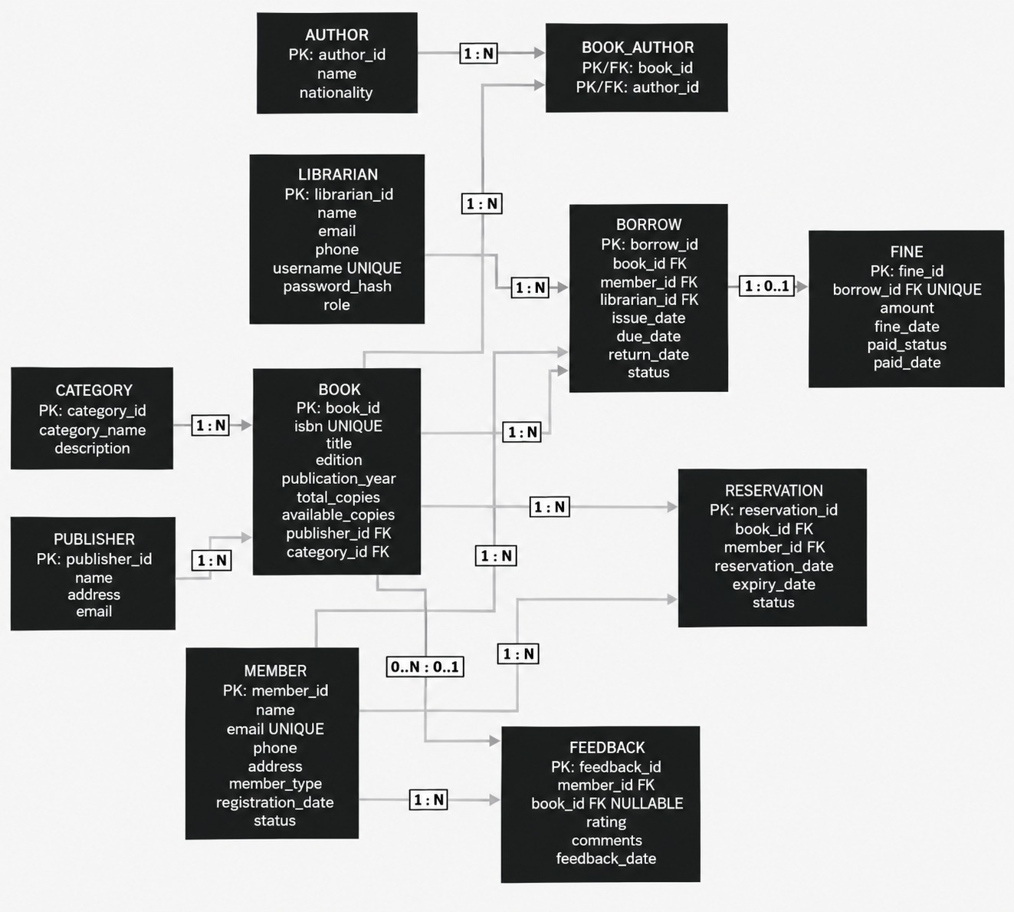
Notes on Keys and Referential Integrity
- BOOK_AUTHOR resolves the M:N relationship between BOOK and AUTHOR. Its composite primary key is (book_id, author_id), and both attributes are foreign keys.
- BOOK.publisher_id and BOOK.category_id implement the 1:N relationships from PUBLISHER and CATEGORY to BOOK.
- BORROW contains foreign keys to BOOK, MEMBER, and LIBRARIAN because each borrowing transaction is associated with one book, one member, and one librarian.
- FINE.borrow_id is both a foreign key and UNIQUE. This implements the 1 : 0..1 relationship between BORROW and FINE, ensuring that a borrowing transaction can have at most one fine.
- FEEDBACK.book_id is nullable because feedback can be submitted either for a specific book or for the library in general.
- LIBRARIAN.role distinguishes administrators from normal librarians. role = 'admin' represents an administrator, so no separate ADMINISTRATOR relation is required.
- isbn, email in MEMBER, and username in LIBRARIAN are candidate/alternate keys enforced using UNIQUE.
- total_copies and available_copies store the aggregate number of physical copies for each book title. A separate BOOK_COPY relation is not required unless individual physical copies need to be tracked using attributes such as barcode, shelf location, condition, or copy status.
- Business rules such as preventing a book from being issued when available_copies = 0, calculating overdue fines, and automatically expiring reservations require database triggers, constraints, or application-level validation.

3.4 Normalization and Functional Dependency Analysis
The Library Management System database is normalized from First Normal Form (1NF) to Second Normal Form (2NF), Third Normal Form (3NF), and Boyce-Codd Normal Form (BCNF).
The analysis begins with an un-normalized conceptual relation containing the main attributes involved in book borrowing. Functional dependencies are identified, candidate keys are justified using attribute closure, and the relation is progressively decomposed to remove partial and transitive dependencies.
1. FIRST NORMAL FORM (1NF)
(a) Un-normalised Starting Relation
Before normalization, the issue-related information can be conceptually represented using one flat relation:
LIBRARY_RAW
(BorrowID, AuthorID, AuthorName, BookID, Title, ISBN, CategoryID, CategoryName, PublisherID, PublisherName, PublisherAddress, MemberID, MemberName, MemberEmail, MemberPhone, LibrarianID, LibrarianName, IssueDate, DueDate, ReturnDate, FineAmount)
Every attribute contains a single atomic value and there are no repeating groups within a row. Therefore, LIBRARY_RAW satisfies 1NF.
Since a book may have multiple authors, a separate row is conceptually required for each author associated with a borrowing transaction. Hence, the natural composite key of this flat relation is:
{BorrowID, AuthorID}
However, several attributes depend only on part of this composite key or indirectly through other attributes. Therefore, the relation requires further normalization.

2. FUNCTIONAL DEPENDENCIES
The relevant functional dependencies are:
Functional Dependency | Significance
BorrowID → BookID, MemberID, LibrarianID, IssueDate, DueDate, ReturnDate, FineAmount | Each borrowing transaction identifies one book, one member, one librarian and its borrowing details.
BookID → Title, ISBN, CategoryID, PublisherID | The details of a book depend only on its book identifier.
CategoryID → CategoryName | Each category identifier determines its category name.
PublisherID → PublisherName, PublisherAddress | Each publisher identifier determines its publisher details.
MemberID → MemberName, MemberEmail, MemberPhone | Each member identifier determines that member's details.
LibrarianID → LibrarianName | Each librarian identifier determines the librarian's name.
AuthorID → AuthorName | Each author identifier determines the author's name.
These functional dependencies are significant because they show which attributes describe individual entities and which attributes describe a borrowing transaction.
For example, the publisher's address depends on PublisherID, not on BorrowID. Keeping all these attributes in one relation would cause update, insertion, and deletion anomalies.

3. CANDIDATE KEY AND ATTRIBUTE CLOSURE
The candidate key of LIBRARY_RAW is:
K = {BorrowID, AuthorID}
To prove this, calculate its attribute closure.
Step 1: Calculate {BorrowID, AuthorID}⁺
Start with:
{BorrowID, AuthorID}⁺ = {BorrowID, AuthorID}
Using:
BorrowID → BookID, MemberID, LibrarianID, IssueDate, DueDate, ReturnDate, FineAmount
we obtain:
{BorrowID, AuthorID, BookID, MemberID, LibrarianID, IssueDate, DueDate, ReturnDate, FineAmount}
Using:
AuthorID → AuthorName
we obtain:
AuthorName
Using:
BookID → Title, ISBN, CategoryID, PublisherID
we obtain:
Title, ISBN, CategoryID, PublisherID
Using:
CategoryID → CategoryName
we obtain:
CategoryName
Using:
PublisherID → PublisherName, PublisherAddress
we obtain:
PublisherName, PublisherAddress
Using:
MemberID → MemberName, MemberEmail, MemberPhone
we obtain:
MemberName, MemberEmail, MemberPhone
Using:
LibrarianID → LibrarianName
we obtain:
LibrarianName
Therefore:
{BorrowID, AuthorID}⁺ = all attributes of LIBRARY_RAW
Hence, {BorrowID, AuthorID} is a superkey.
Step 2: Minimality
Consider the proper subsets.
{BorrowID}⁺ determines the borrowing, book, category, publisher, member and librarian information, but it does not determine AuthorID or AuthorName.
Therefore:
{BorrowID} is not a superkey.
Similarly:
{AuthorID}⁺ = {AuthorID, AuthorName}
It does not determine BorrowID or the remaining attributes.
Therefore:
{AuthorID} is not a superkey.
Since neither proper subset is a superkey, {BorrowID, AuthorID} is minimal.
Therefore:
{BorrowID, AuthorID} is the candidate key of LIBRARY_RAW.

4. NORMALIZATION PROCESS
(a) 1NF
LIBRARY_RAW contains only atomic attributes and has the defined candidate key {BorrowID, AuthorID}.
Therefore:
LIBRARY_RAW ∈ 1NF

(b) 2NF
A relation is in 2NF if it is in 1NF and every non-key attribute is fully functionally dependent on the whole candidate key.
The candidate key is:
{BorrowID, AuthorID}
However:
BorrowID → BookID, MemberID, LibrarianID, IssueDate, DueDate, ReturnDate, FineAmount
Here, these attributes depend only on BorrowID, which is a proper subset of the composite key.
This is a partial dependency.
Similarly:
AuthorID → AuthorName
Here, AuthorName depends only on AuthorID, another proper subset of the candidate key.
Therefore, LIBRARY_RAW violates 2NF.
To remove these partial dependencies, the information is decomposed into relations based on the attributes on which they actually depend.
The resulting relations include:
BORROW_FULL
(BorrowID, BookID, MemberID, LibrarianID, IssueDate, DueDate, ReturnDate, FineAmount, Title, ISBN, CategoryID, CategoryName, PublisherID, PublisherName, PublisherAddress, MemberName, MemberEmail, MemberPhone, LibrarianName)
AUTHOR
(AuthorID, AuthorName)
BOOK_AUTHOR
(BookID, AuthorID)
The BOOK_AUTHOR relation represents the many-to-many relationship between BOOK and AUTHOR.
These relations no longer contain partial dependencies and therefore satisfy 2NF.

(c) 3NF
A relation is in 3NF if it is in 2NF and contains no transitive dependency of a non-key attribute on a key.
In BORROW_FULL, the key is BorrowID.
The following transitive dependencies exist:
BorrowID → BookID → Title, ISBN, CategoryID, PublisherID
BorrowID → BookID → CategoryID → CategoryName
BorrowID → BookID → PublisherID → PublisherName, PublisherAddress
BorrowID → MemberID → MemberName, MemberEmail, MemberPhone
BorrowID → LibrarianID → LibrarianName
Therefore, BORROW_FULL violates 3NF.
The relation is decomposed into:
BORROW
(BorrowID, BookID, MemberID, LibrarianID, IssueDate, DueDate, ReturnDate, Status)
BOOK
(BookID, Title, ISBN, Edition, PublicationYear, TotalCopies, AvailableCopies, CategoryID, PublisherID)
CATEGORY
(CategoryID, CategoryName, Description)
PUBLISHER
(PublisherID, PublisherName, PublisherAddress, Phone, Email)
MEMBER
(MemberID, MemberName, MemberEmail, MemberPhone, Address, MemberType, RegistrationDate, Status)
LIBRARIAN
(LibrarianID, LibrarianName, Email, Phone, Username, PasswordHash, Role, Status)
AUTHOR
(AuthorID, AuthorName, Nationality)
BOOK_AUTHOR
(BookID, AuthorID)
The optional fine information is represented separately:
FINE
(FineID, BorrowID, Amount, FineDate, PaidStatus, PaidDate)
Since BorrowID is unique in FINE, at most one fine can exist for a borrowing transaction.
After decomposition, the non-key attributes in each relation depend directly on the key and not transitively through another non-key attribute.
Therefore, these relations satisfy 3NF.

(d) Additional Relations from the ER Design
The remaining relations from the ER design are:
RESERVATION
(ReservationID, BookID, MemberID, ReservationDate, ExpiryDate, Status)
Here:
ReservationID → BookID, MemberID, ReservationDate, ExpiryDate, Status
Therefore, all non-key attributes depend directly on the candidate key ReservationID.
Hence, RESERVATION is already in BCNF.
FEEDBACK
(FeedbackID, MemberID, BookID, Rating, Comments, FeedbackDate)
Here:
FeedbackID → MemberID, BookID, Rating, Comments, FeedbackDate
Again, all non-key attributes depend directly on the candidate key FeedbackID.
Therefore, FEEDBACK is already in BCNF.

5. BOYCE-CODD NORMAL FORM (BCNF)
A relation is in BCNF if, for every non-trivial functional dependency:
X → Y
X must be a superkey.
The final relations are checked as follows:
- In BORROW, BorrowID is the determinant and is the primary key.
- In BOOK, BookID is the determinant and is the primary key.
- In CATEGORY, CategoryID is the determinant and is the primary key.
- In PUBLISHER, PublisherID is the determinant and is the primary key.
- In MEMBER, MemberID is the determinant and is the primary key.
- In LIBRARIAN, LibrarianID is the determinant and is the primary key.
- In AUTHOR, AuthorID is the determinant and is the primary key.
- In FINE, FineID is a candidate key and BorrowID is also a candidate key because it is unique.
- In RESERVATION, ReservationID is the determinant and is the primary key.
- In FEEDBACK, FeedbackID is the determinant and is the primary key.
- In BOOK_AUTHOR, (BookID, AuthorID) is the complete key and there are no non-key attributes.
Therefore, every determinant in the final relations is a superkey.
Hence, all final relations satisfy BCNF.

6. Conclusion
The Library Management System database is successfully normalized through the following stages:
1NF → 2NF → 3NF → BCNF
The normalization process removes:
- Partial dependencies caused by the composite key in the initial flat relation.
- Transitive dependencies between borrowing records and book, category, publisher, member, and librarian information.
- Data redundancy and update, insertion, and deletion anomalies.
The final schema consists of the following relations:
PUBLISHER, CATEGORY, AUTHOR, BOOK, BOOK_AUTHOR, MEMBER, LIBRARIAN, BORROW, FINE, RESERVATION, and FEEDBACK
All final relations satisfy BCNF, providing a well-structured and consistent relational database design.

